Introduction:

This is a web system for students grades , designed by three software experts . This system use some algorithms to modify the original grades , allowing customers to fulfill requirements .

Product Description:

This system includes the following function . First , there is an user interface containing two input bars . For security issue , the system will examine the correctness of the information typed by users , then turning logging page to main page . Second , because students and authorities have numerous subject to select , in the main page , we design a subject list in the form of scroll menu to deal with the problems . Third , it can calculate average score and standard deviation of each exam . Fourth , upon pressing the certain button , the system will show up grading trend of selected student in current course . Fifth , it also can demonstrate the distribution of the test grades in the form of chart . Sixth, when student who is on the edge of failing , the system will give warning messages to that student and the teacher . Seventh , Students who desire to know each grading component will be indicated by the information the teachers present . Eighth, in the case of the user who might be confused of how to use the system , they can access the FAQ service by pressing the button in the web page . Nineth , the database will store the information ( grades , logging account and password , courses ) of the students .

1. Calculation of average scores:

For every teacher , they can type in student’s scores or input from csv file . From viewpoint of personal scores , the system will automatically calculate the average scores based on weighted points . On the other hand , the system will calculate the average scores of the whole class by mean method .

1. Demonstration of scores trend (single student):

Based on the scores in the database , the system will present run chart . Users can click on the button and the chart of each student’s scores will show up .

1. Distribution(class student):

Users can also click the other button , then , the bar chart of one specific test of the whole class will present .

1. Notification of failing grades:

After the midterm , the system will sent out message for each student whose grade is under sixty .

1. Class grading information of each test:

When clicking the button of the class information , the introduction of the class and how much percentage of each exam and homework counts .

1. Logging interface:

To identify the user’s identity , the system will determine which interface will forward to and also the prevention of hackers .

1. Subject list:

The walking menu provided users the function of choosing which subject will be specified . And the page will redirect to the main page .

1. Online User’s Manual(FAQ):

This page is for someone who has issues about the function . And the system also provides online instant service to help someone in need right now .

1. Modification of the grades:

On account of too many students will be failed , the system will provide teacher to choose from numerous formulas to modify scores(e.g.one of the formula is $\sqrt{x}×10$) .

DFD:

Level0: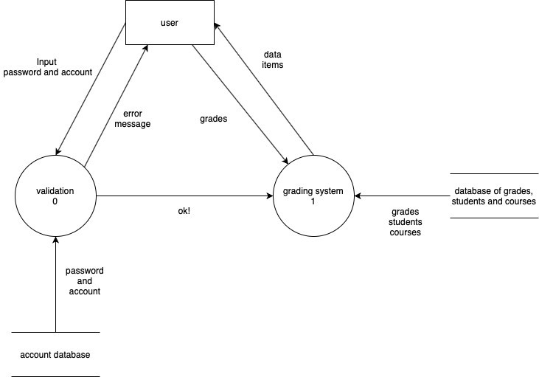

Level1: 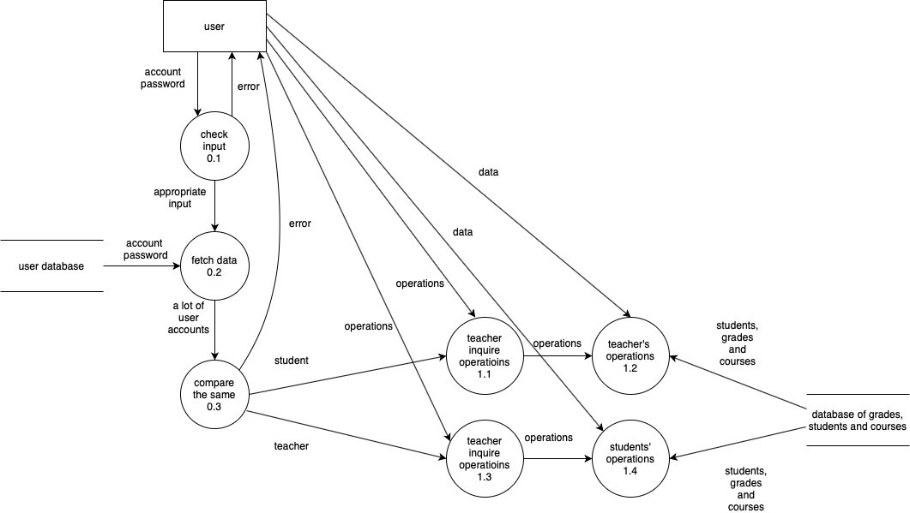

Level2:

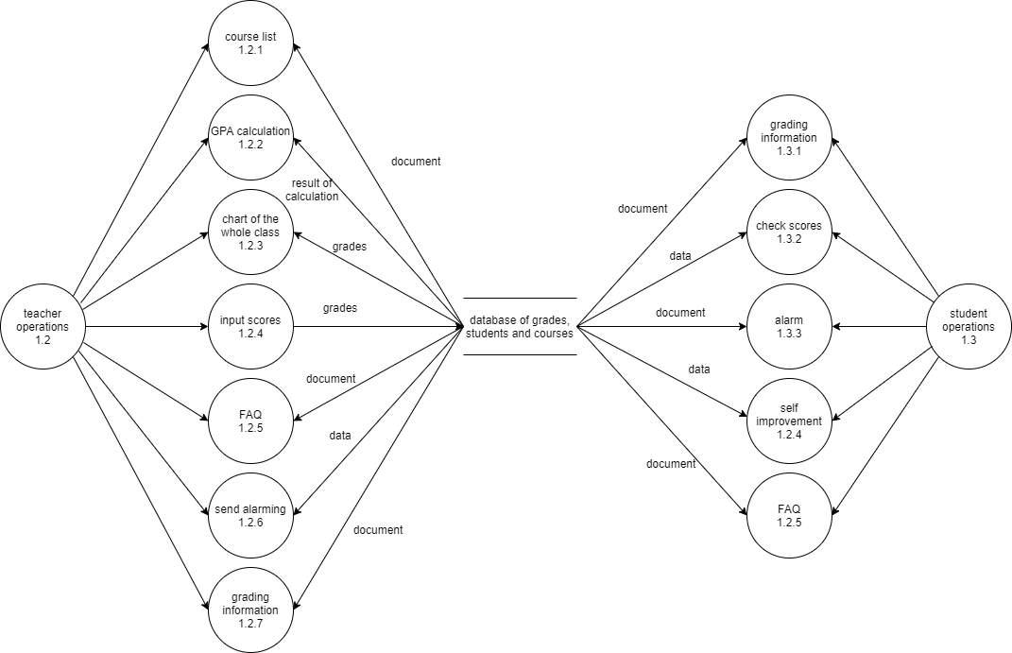

User-case diagram:

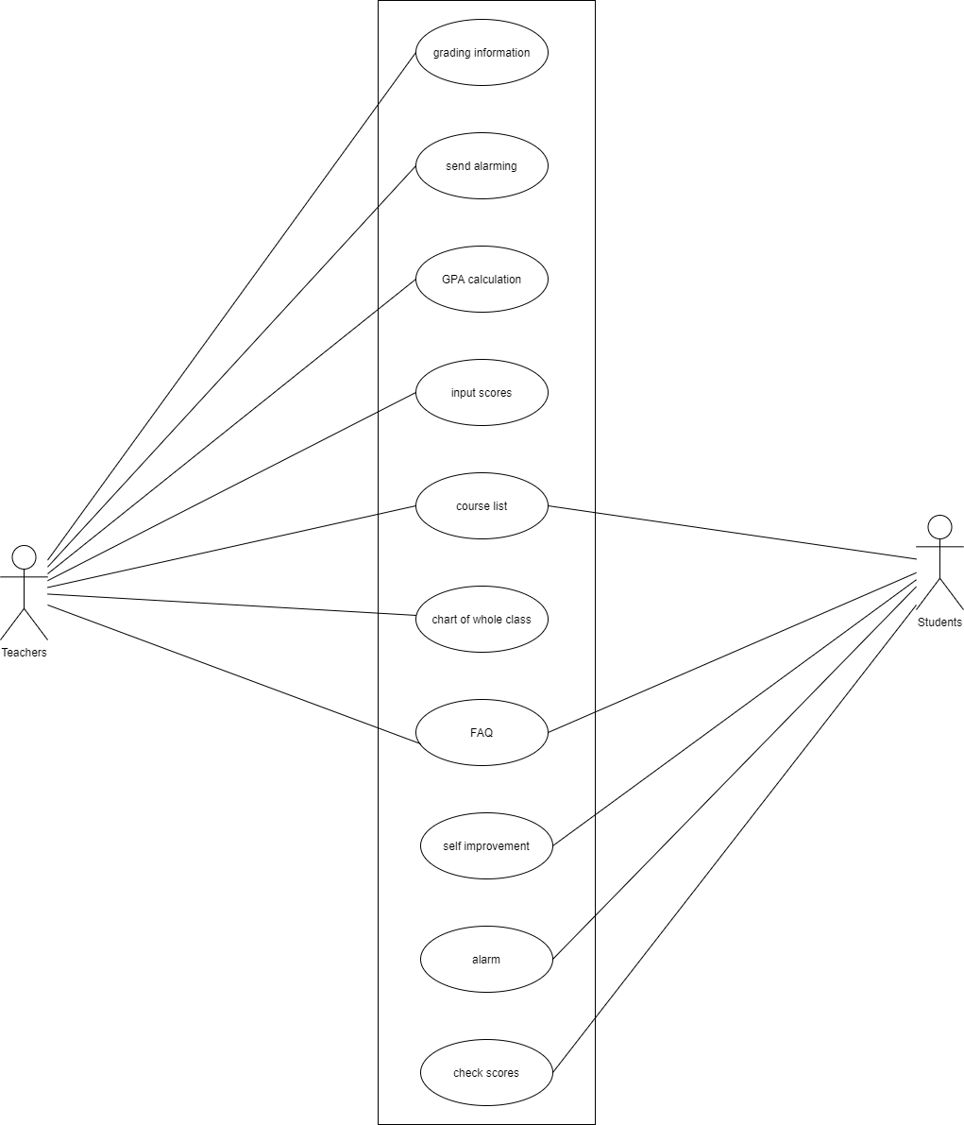

GUI:

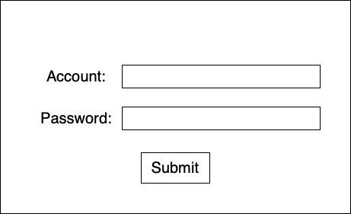

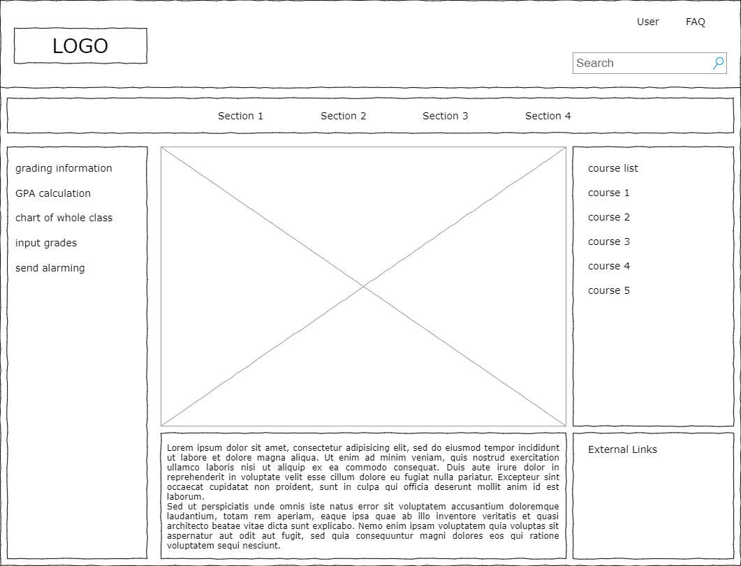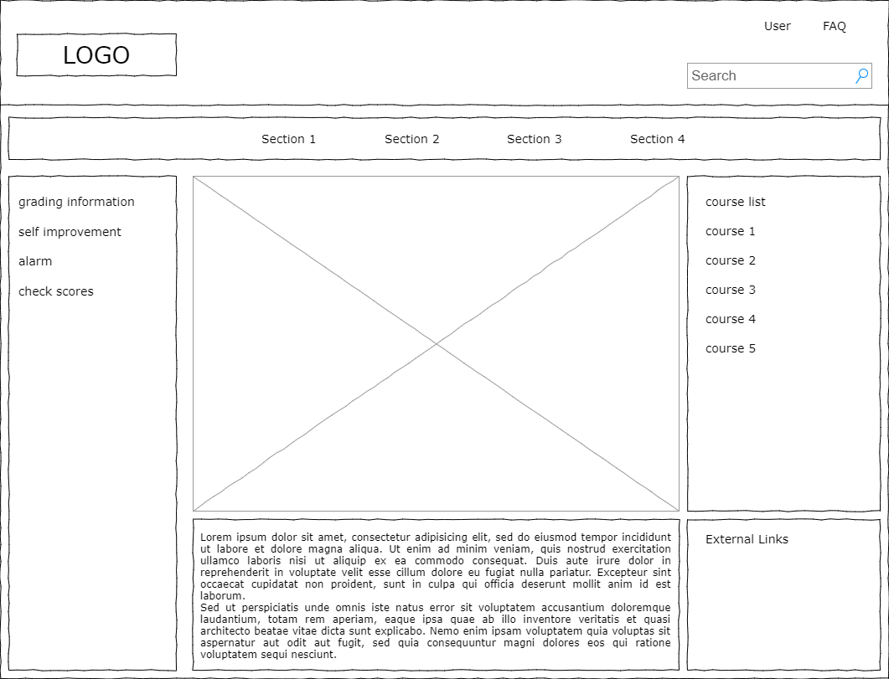

Sequence Diagram: For teacher

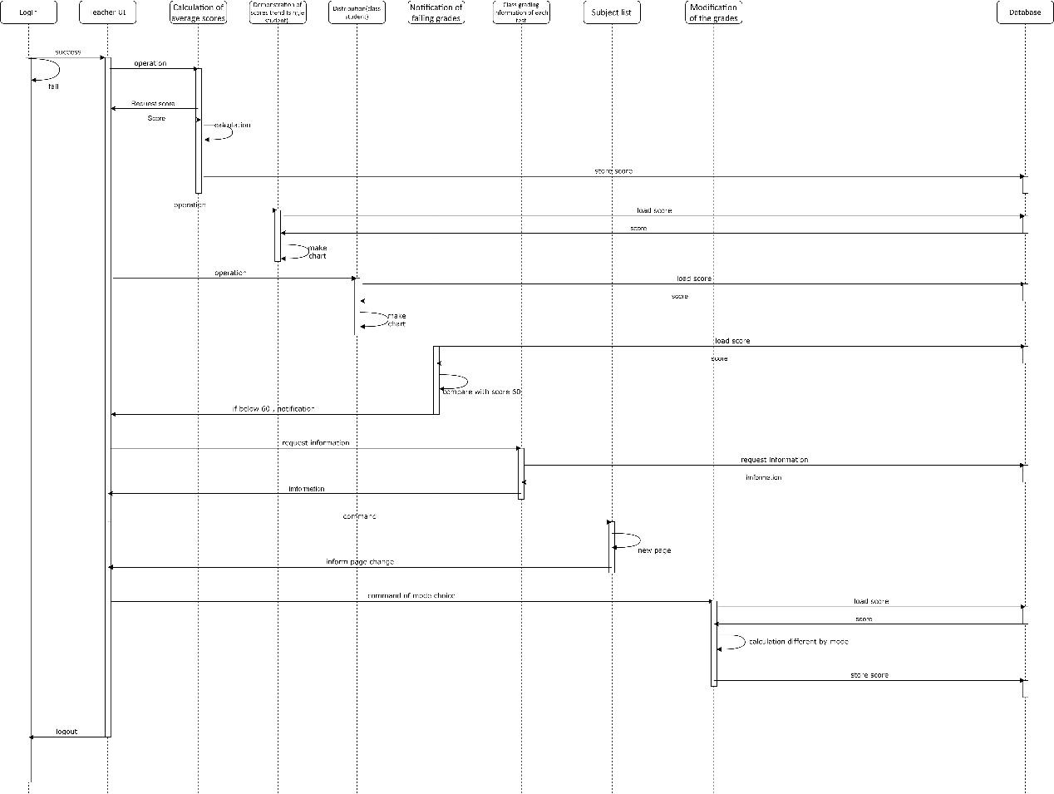

Sequence Diagram: For student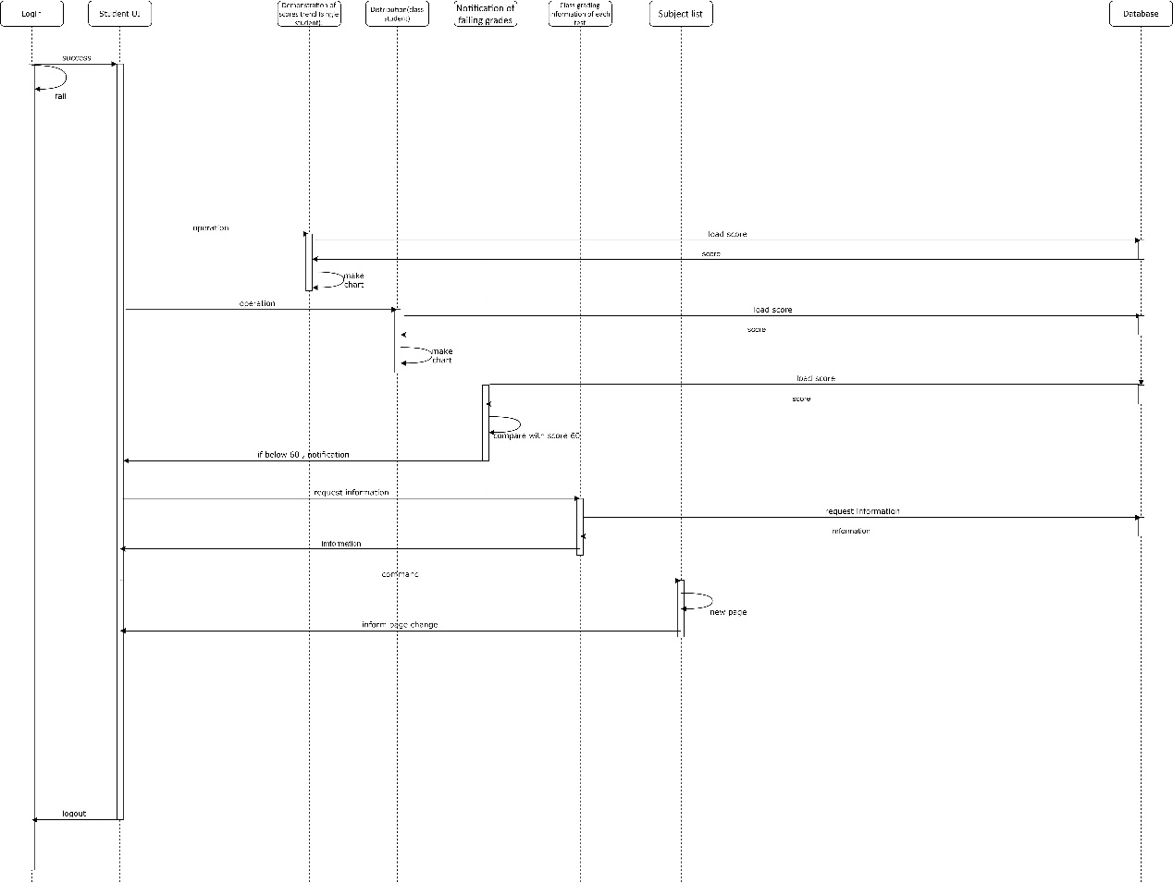

Nonfunction:

This website can support utmost 300 users to access to the web . The response time of web server should less than 10 msec . This software has simple and clean user interface . This website has been penetrate testing by professional hacker , that this web can prevent DDOS attack and so on .

Has a dual 10Gbps networks interface , using multi-core CPU (eg intel i9-109xx),the Ram is 64GB(DDR4) . Operating system is Debian-based linux . The database is Oracle database server.

Cost estimation :

COCOMO organic:

2.4\*4^1.05

10.289025240348414376444860720224/‬pm

effort:

2.5\*10.289025240348414376444860720224‬^0.38

6.0623669046804727313963586629491/month

Test case:

1. Error input of account and password:

Verifying the identities of the users , and preventing from users’ error inputs . And also the authentication can prevent from being hacked by malicious students .

1. Input scores are out of range:

The default range of the score is between 0 to 100 , if the teacher input the score which is outside the range , the system should be detecting the error.

1. Boundary checking after modification of the scores:

Modification of the grades which some student will be over 100 points , so the system should warning teacher before this kind of operation .

Summary:

The system that we designed has fulfilled the need of the customer’s expectation . The process of constructing this system is tough , first we need to deal with the issues of the attack from crackers . They may type in unusual id and exploiting the vulnerable of the web system , then compromising the website . Second , when there are too many users online at the same time , we need to make sure our server can handle properly . To deal with those problems , we do penetration test and also provide enough server to sustain huge amount of people online at the same time .

Also our team has experienced this system , and proving that the interface is neat and function of calculation and inputting scores is easy to operate .